How to setup Email on iPhone Mail App

1. Go to the Settings icon in your iPhone Home Screen
2. Select Mail from the Settings menu  
     
   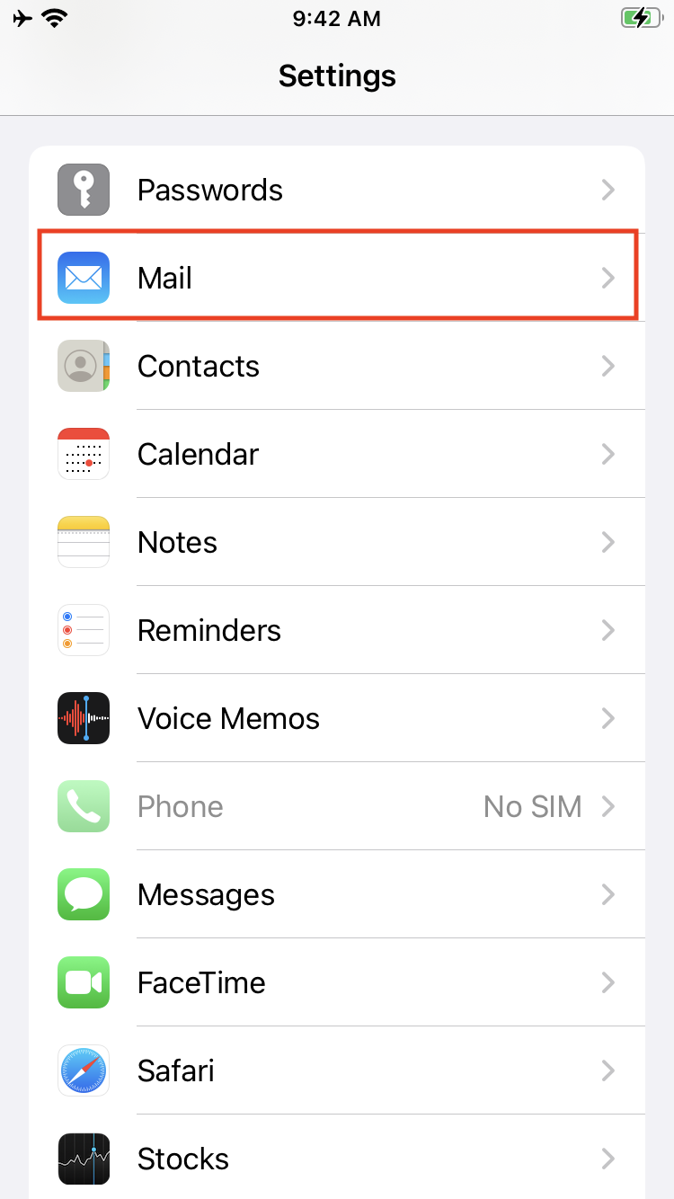
3. Tap the Add Account… option under the Mail settings  
     
   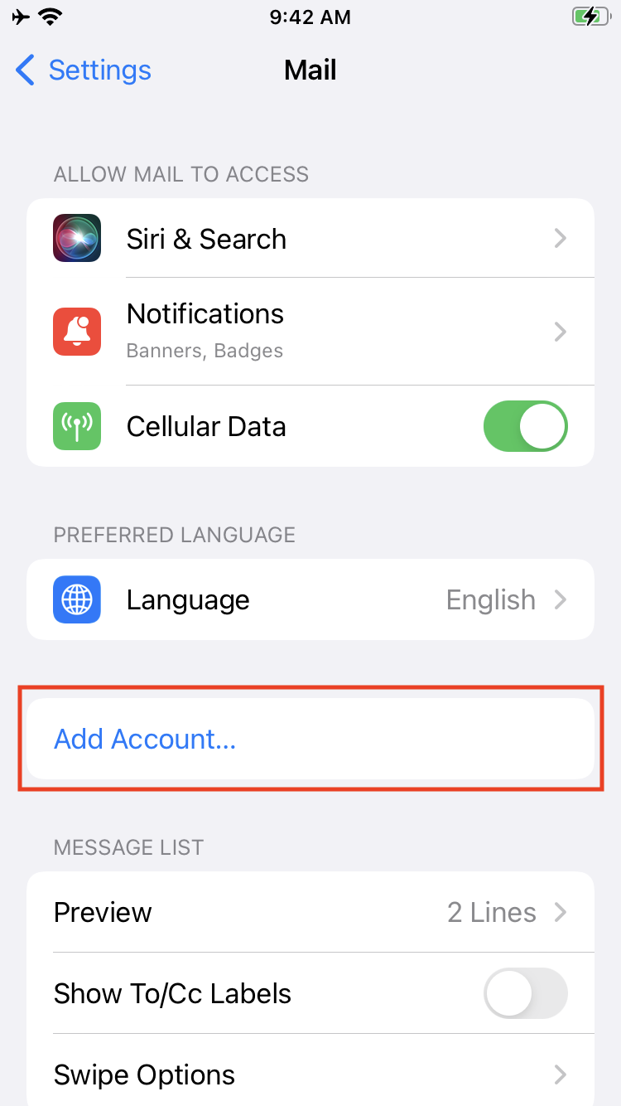
4. Select the Microsoft Exchange option  
     
   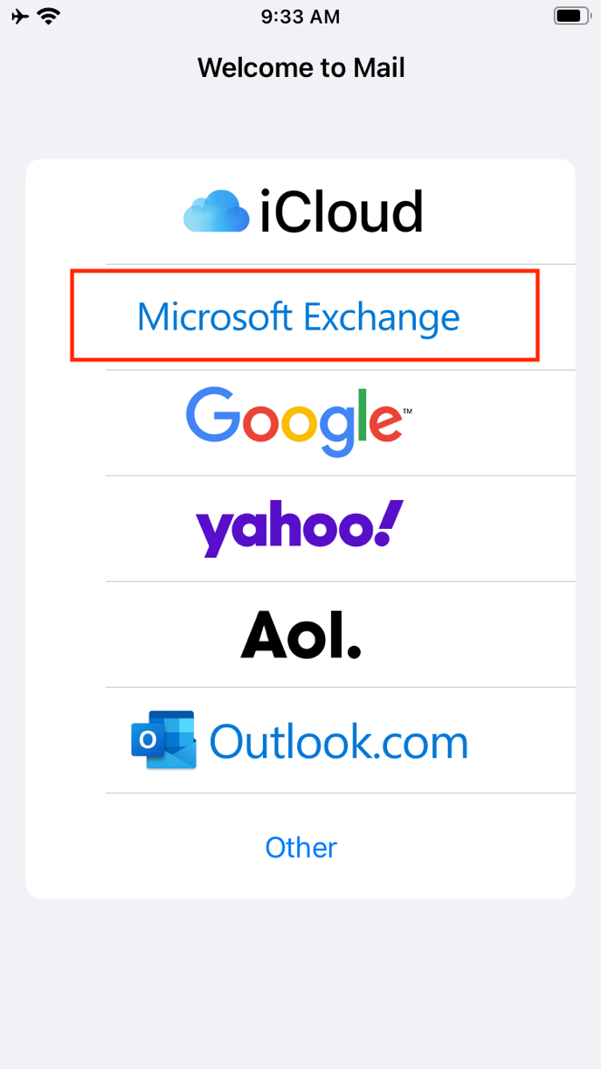
5. Enter the email as your [username@kaust.edu.sa](mailto:username@kaust.edu.sa), enter a description like Exchange and tap Next  
     
   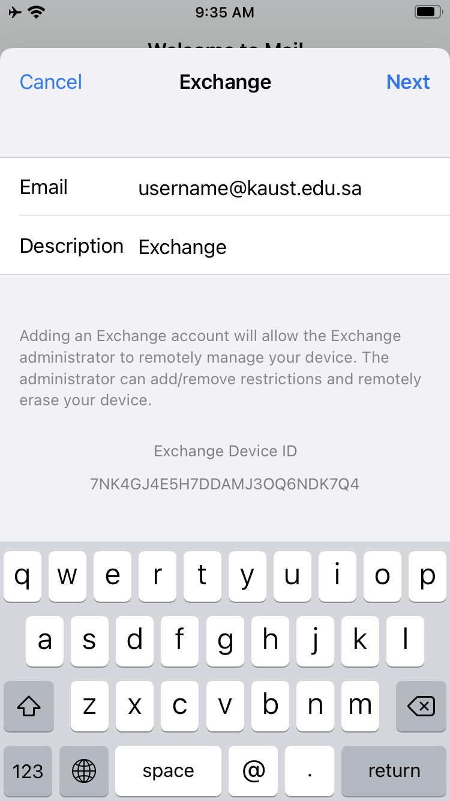 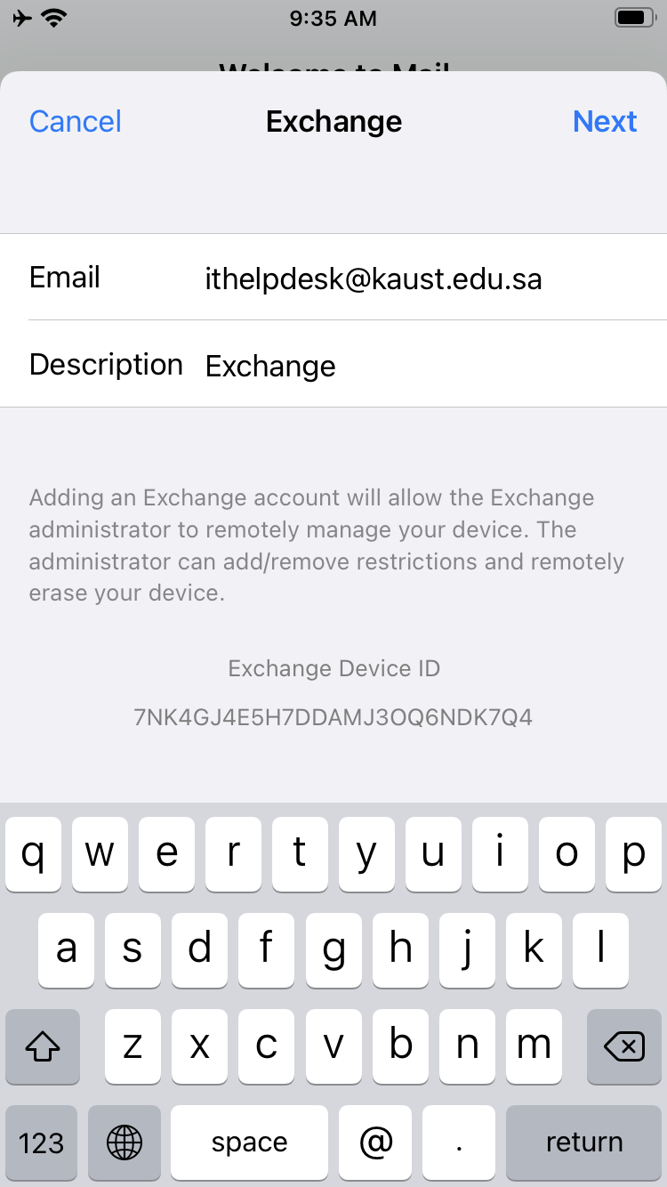
6. Select the Sign In option on the pop-up window  
     
   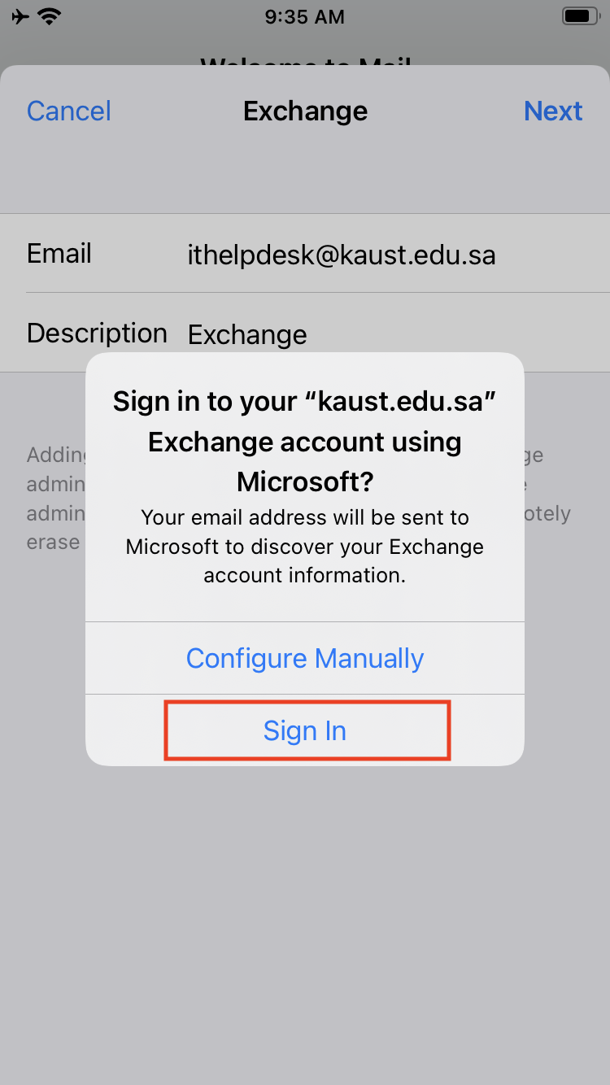
7. On the KAUST Login screen enter your password and tap Sign in to authenticate.  
     
   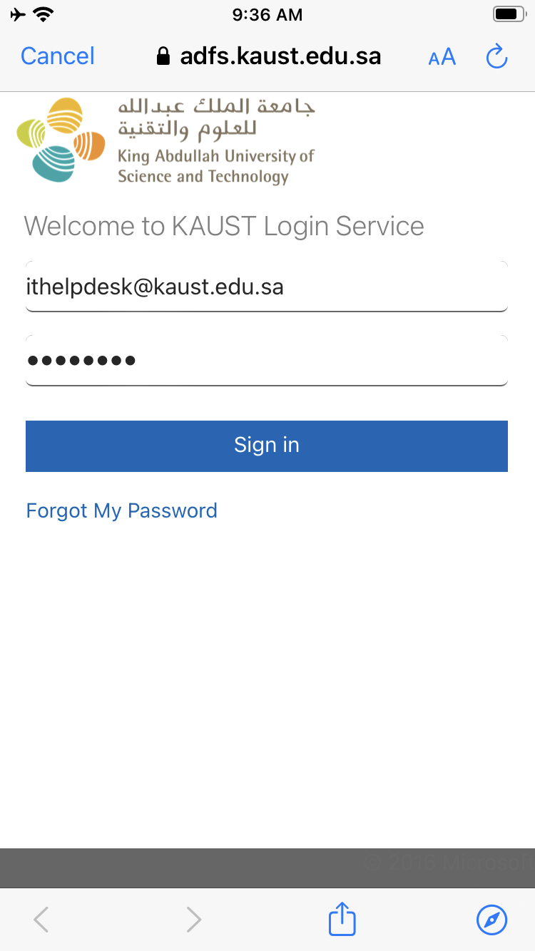
8. Tap the Accept button to grant the required permissions to the Mail application  
     
   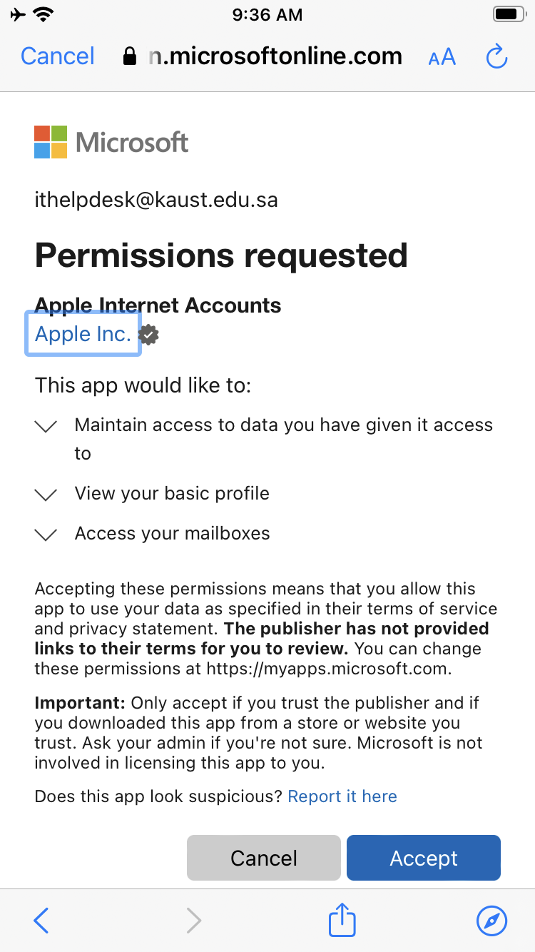
9. You should receive a checkmark next to your email to indicate a successful setup. Tap Save to finish the setup.  
     
   